|  |
| --- |
| **Third Year of E &TC Engineering(2019Course):**  **Elective -1 Fundamentals of JAVA Programming** |

|  |
| --- |
| **Virtual LAB Links:**  **Link** of the Virtual Lab: **https://java-iitd.vlabs.ac.in/** |

**Student Name: Hemant Rohidas Murkute**

**Year: TE Class: 1**

**Roll Number: 07**

**Date of execution: 01/10/2025**

|  |  |  |  |
| --- | --- | --- | --- |
| **Sr. No** | **Experiment Name** | **Virtual Lab Name** | **Conclusion/Understanding of student after performing experiment** |
| **1** | **Introduction to Java Programming Language** | **Core Java Programming** | **We learned Java basics, its history, features, and environment setup. Finally, we compiled and executed our first Java program, understanding JDK, JRE, and JVM.** |
| **2** | **Creating Classes and their Objects in Java** | **Core Java Programming** | **We learned that a class is a blueprint and an object is its instance with state and behavior. Using the new keyword, we can create objects and access their fields and methods.** |
| **3** | **Using constructors for creating Objects** | **Core Java Programming** | **Constructors in Java are special methods used to initialize objects at creation time. They share the class name, have no return type, and can be default (no-argument) or parameterized. They ensure objects start with proper values instead of defaults like 0 or null.** |

**Attach any 3 experiments screenshots**

1. **Introduction to Java Programming Language**

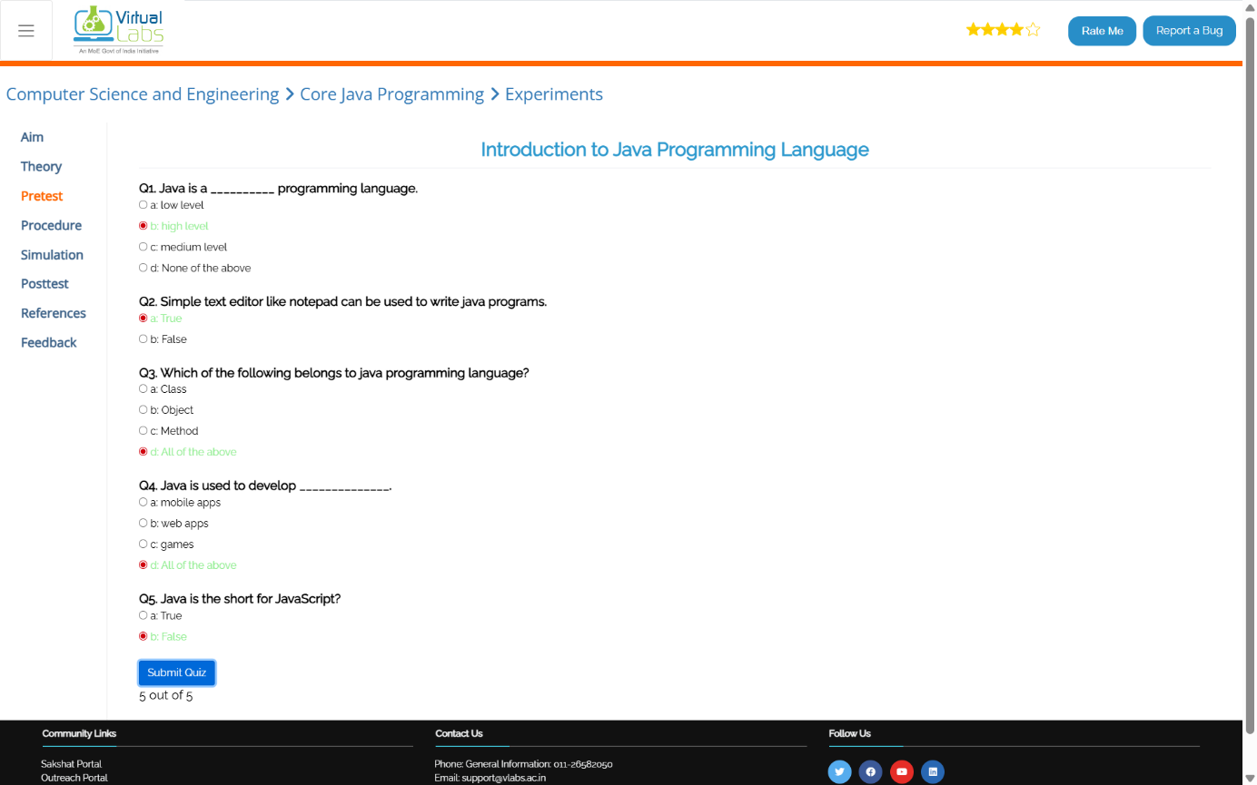

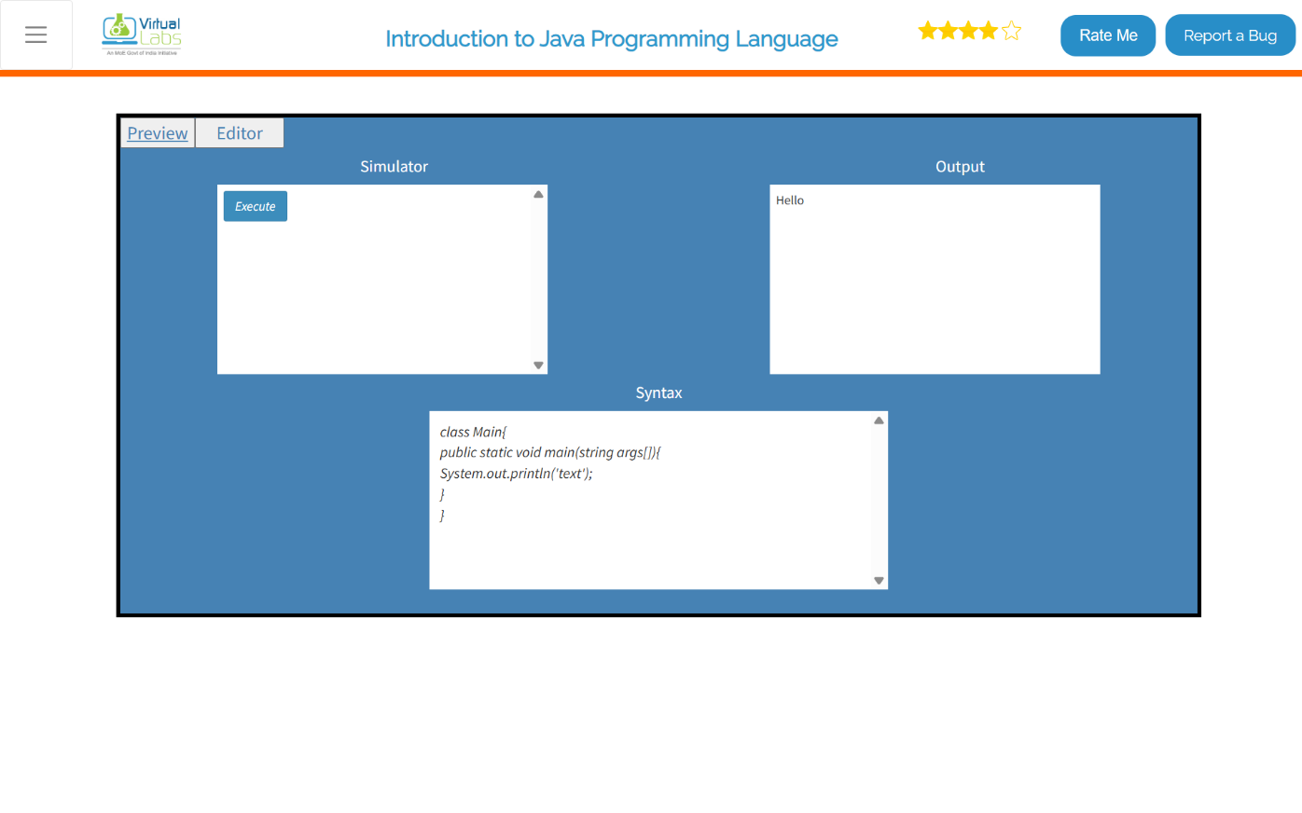

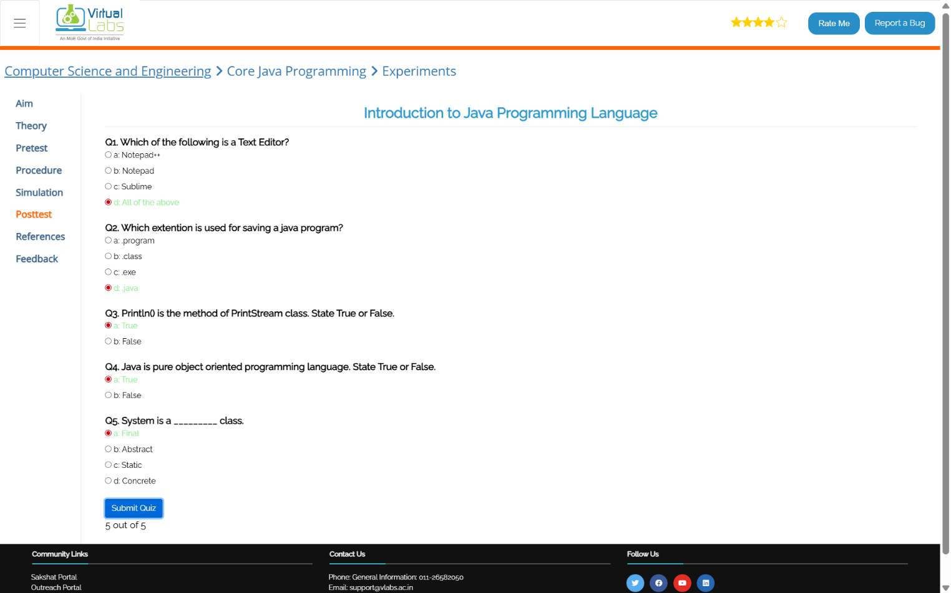

**Conclusion:  
  
We learned Java basics, its history, features, and environment setup. Finally, we compiled and executed our first Java program, understanding JDK, JRE, and JVM.**

1. **Creating Classes and their Objects in Java**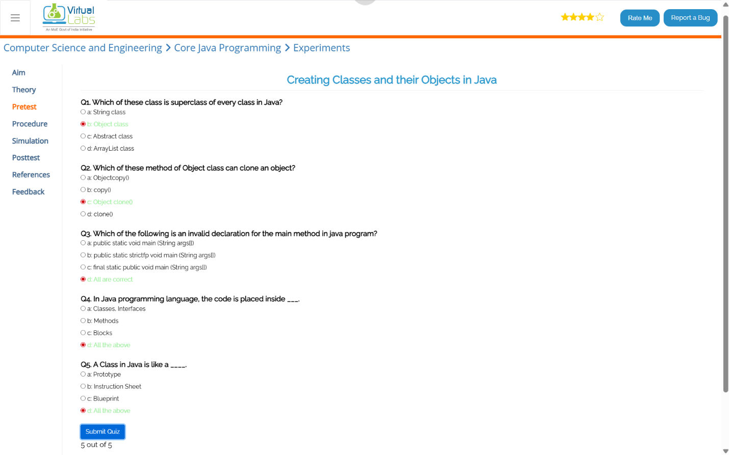

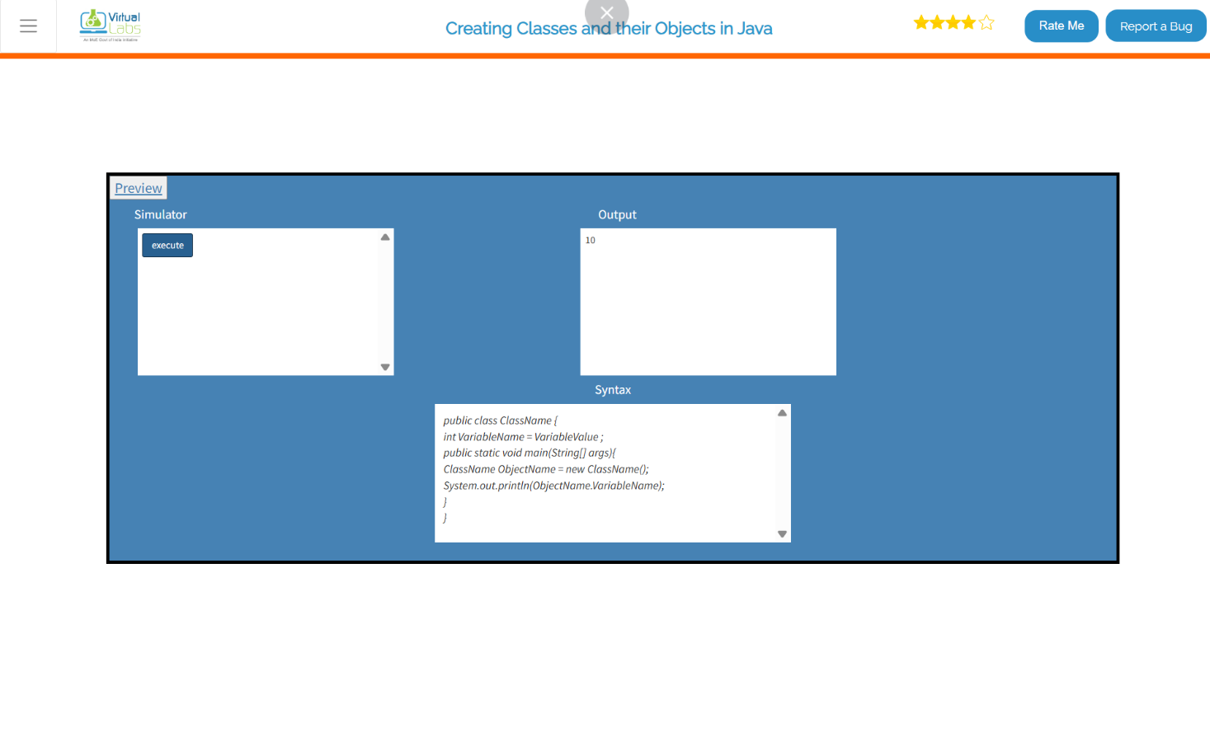

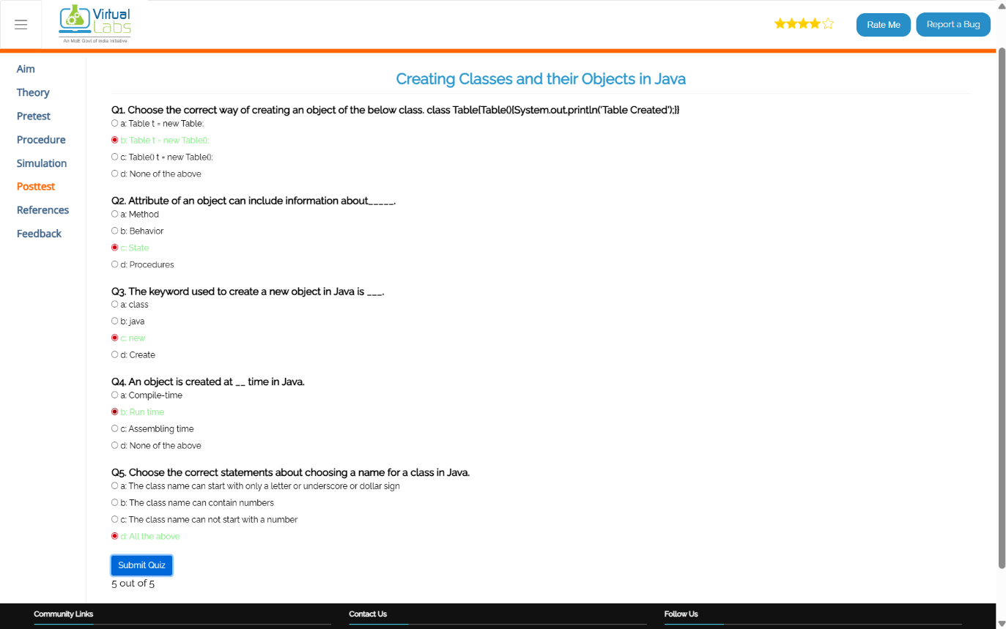

**Conclusion:  
  
We learned that a class is a blueprint and an object is its instance with state and behavior. Using the new keyword, we can create objects and access their fields and methods.**

1. **Using constructors for creating Objects  
   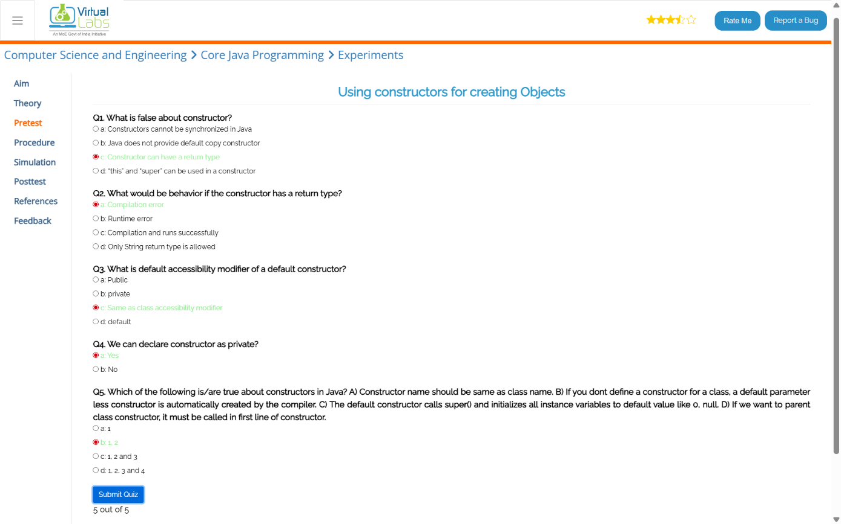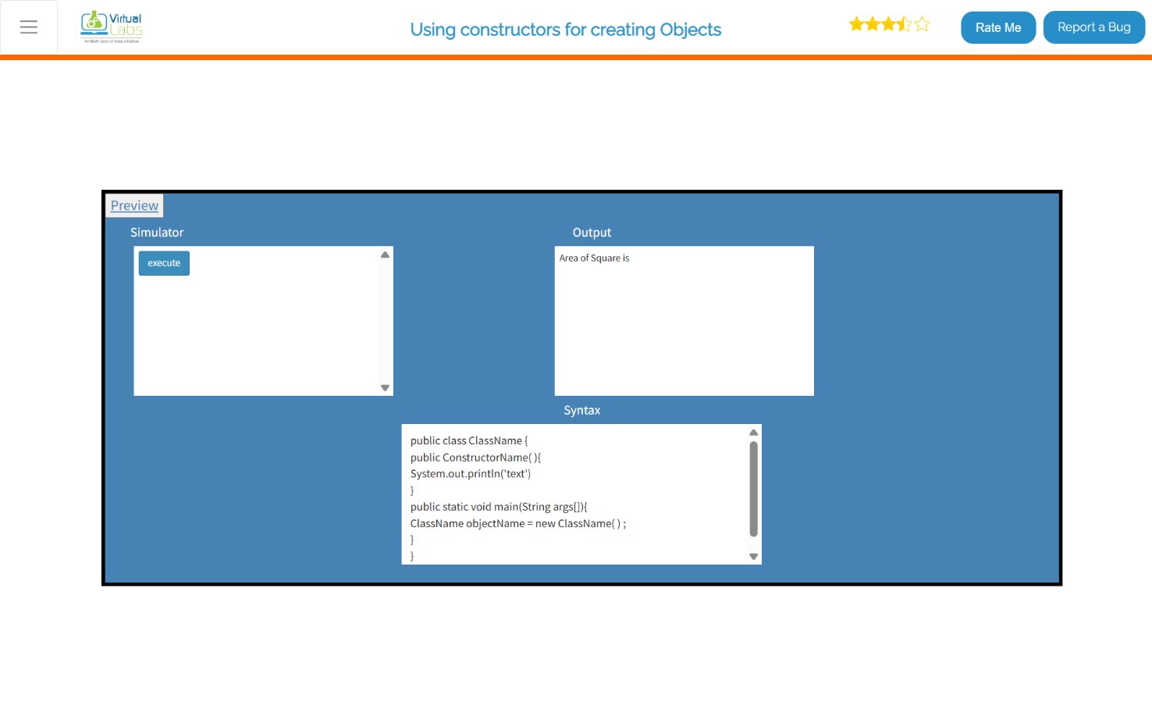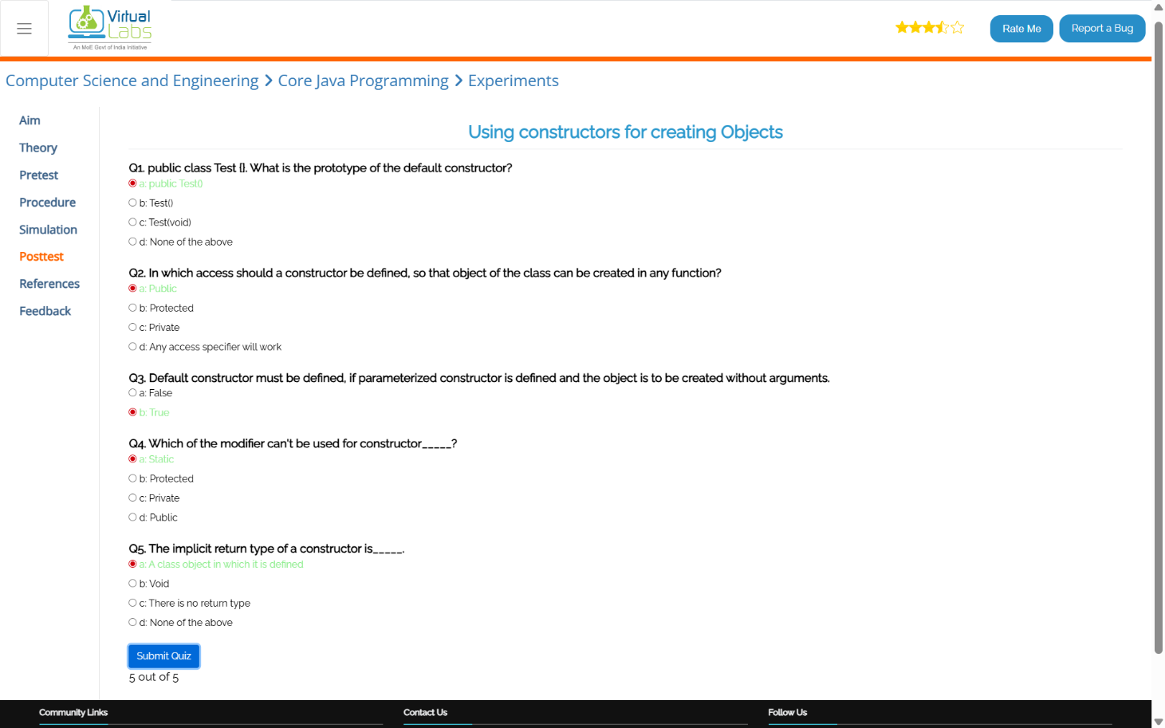  
     
   Conclusion:  
     
   Constructors in Java are special methods used to initialize objects at creation time. They share the class name, have no return type, and can be default (no-argument) or parameterized. They ensure objects start with proper values instead of defaults like 0 or null.**